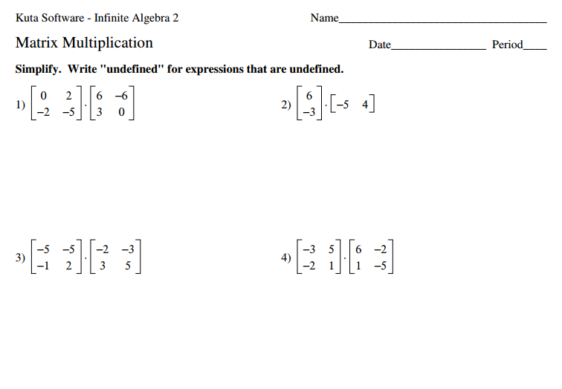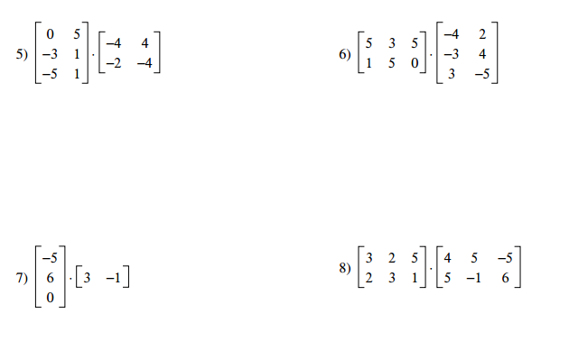
4
05
$-3$3
2
4
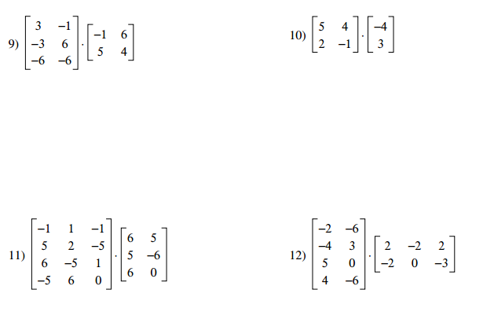
4
3
$$-5$$

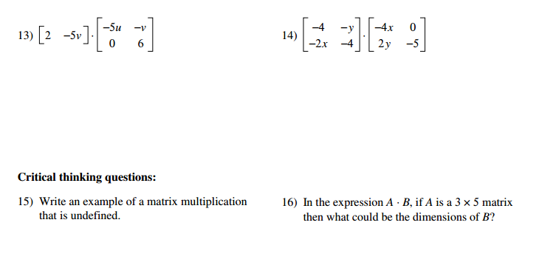
$$\left[\begin{matrix}0 & -4x \\ 2y & -5\end{matrix}\right]$$
-y 0
5
Matrix Equality period_______ Name ________________________

Solve for the missing matrix (denoted by the capital variable).

